**S3 Version**

Versioning in Amazon S3 is a means of keeping multiple variants of an object in the same bucket. You can use the S3 Versioning feature to preserve, retrieve, and restore every version of every object stored in your buckets. With versioning you can recover more easily from both unintended user actions and application failures. After versioning is enabled for a bucket, if Amazon S3 receives multiple write requests for the same object simultaneously, it stores all of those objects.

Versioning-enabled buckets can help you recover objects from accidental deletion or overwrite. For example, if you delete an object, Amazon S3 inserts a delete marker instead of removing the object permanently. The delete marker becomes the current object version. If you overwrite an object, it results in a new object version in the bucket. You can always restore the previous version.

**Note:** You can’t protect the data’s loss in S3 bucket without version enabling.

Buckets can be in one of three states:

* Unversioned (the default)
* Versioning-enabled
* Versioning-suspended

Upload object in S3 bucket and verify the URL.

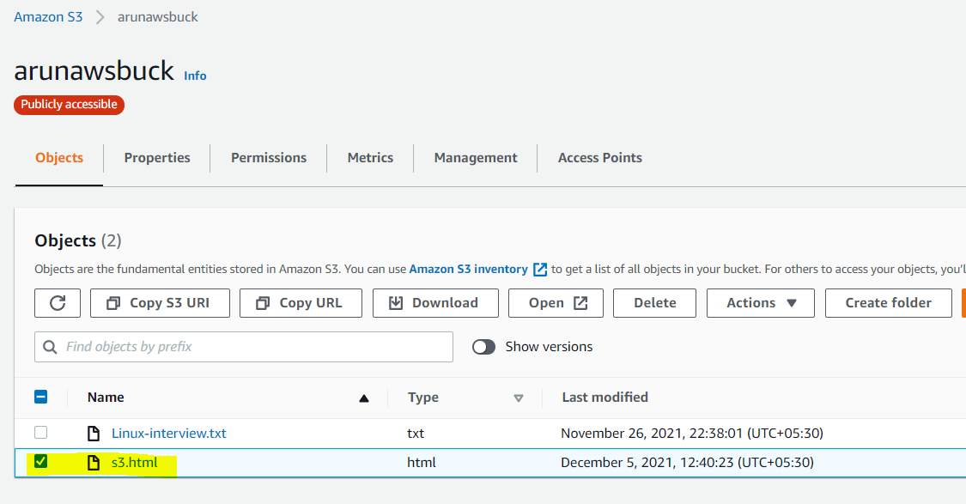

Access object by using URL

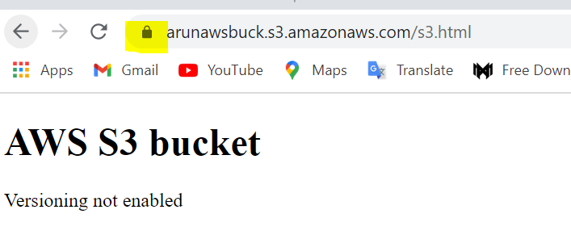

Enable bucket versioning

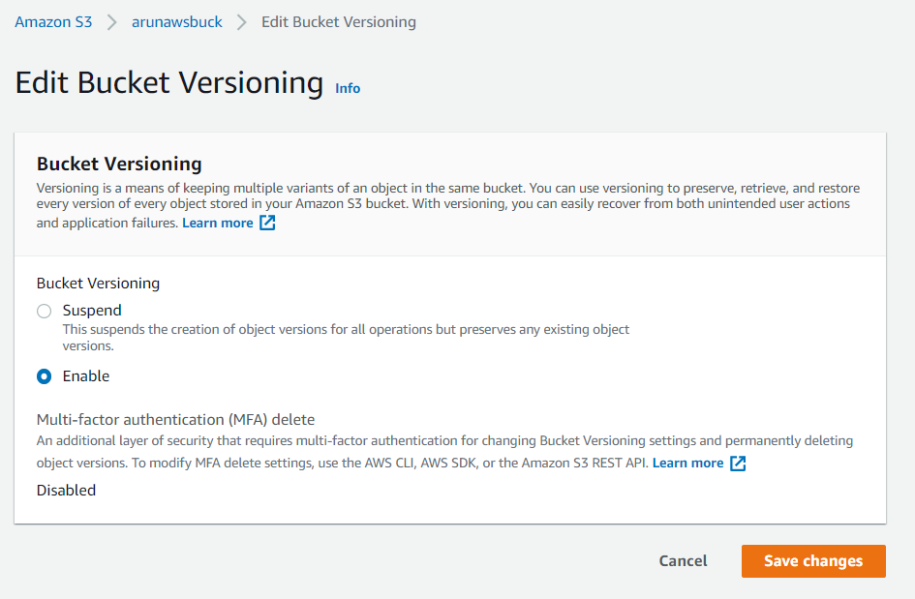

Now edit object and re-upload into bucket

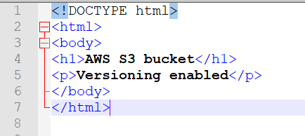

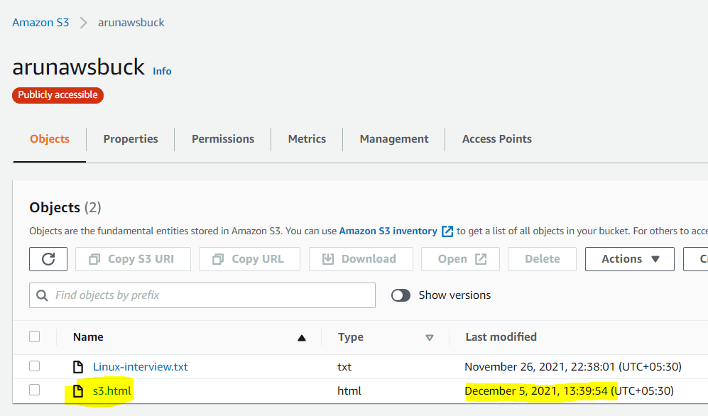

Validated the modified object in the console.

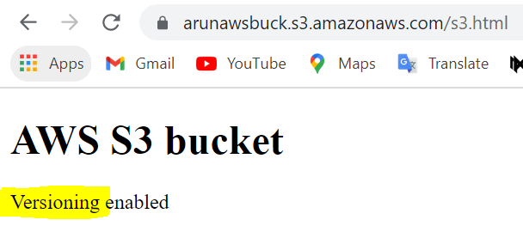

You can validate the version ID for the object. Highlighted ID is after object modified and below one is exciting file you may download the exciting file.

